**Venta de pizzas – Consultas SQL**

# A. KPI’s (Key Performance Indicators / Indicadores claves de rendimiento)

**1. Ingresos Totales:**

SELECT SUM(total_price) AS Ingresos_Totales FROM pizza_sales

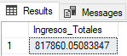

**2. Ingreso Por Orden Promedio**

SELECT (SUM(total_price) / COUNT(DISTINCT order_id)) AS Ingreso_Por_Orden_Promedio FROM pizza_sales

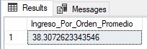

**3. Pizzas Vendidas**

SELECT SUM(quantity) AS Pizzas_Vendidas FROM pizza_sales

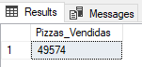

**4. Total De Ordenes**

SELECT COUNT(DISTINCT order_id) AS Total_Ordenes FROM pizza_sales

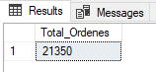

**5. Promedio De Pizzas Por Orden**

SELECT CAST(CAST(SUM(quantity) AS DECIMAL(10,2)) /

CAST(COUNT(DISTINCT order_id) AS DECIMAL(10,2)) AS DECIMAL(10,2))

AS Promedio_Pizzas_Por_Orden

FROM pizza_sales

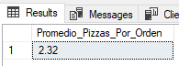

# **B. Tendencia diaría del total de pedidos**

SELECT DATENAME(DW, order_date) AS Orden_día, COUNT(DISTINCT order_id) AS Pedidos_totales

FROM pizza_sales

GROUP BY DATENAME(DW, order_date)

***Output:***

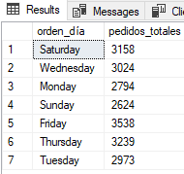

# C. Tendencia mensual del total de pedidos

select DATENAME(MONTH, order_date) as Nombre_mes, COUNT(DISTINCT order_id) as Pedidos_totales

from pizza_sales

GROUP BY DATENAME(MONTH, order_date)

***Output***

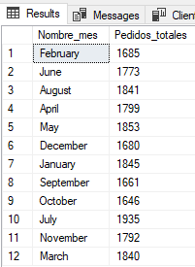

# D. Porcentaje de venta por Pizza Category

SELECT pizza_category AS Categoria_Pizzas, CAST(SUM(total_price) AS DECIMAL(10,2)) as Ingresos_Totales,

CAST(SUM(total_price) * 100 / (SELECT SUM(total_price) from pizza_sales) AS DECIMAL(10,2)) AS PCT

FROM pizza_sales

GROUP BY pizza_category

***Output***

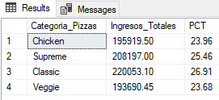

# E. Porcentaje de ventas por Pizza Size

SELECT pizza_size AS Tamaño_Pizzas, CAST(SUM(total_price) AS DECIMAL(10,2)) as Ingresos_Totales,

CAST(SUM(total_price) * 100 / (SELECT SUM(total_price) from pizza_sales) AS DECIMAL(10,2)) AS PCT

FROM pizza_sales

GROUP BY pizza_size

ORDER BY pizza_size

***Output***

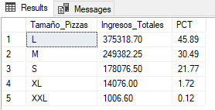

# F. Total de pizzas vendidas por Pizza Category

SELECT pizza_category AS Categoria_Pizza,

SUM(quantity) as Cantidad_Total_Vendida

FROM pizza_sales

GROUP BY pizza_category

ORDER BY Total_Quantity_Sold DESC

***Output:***

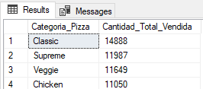

# G. Top 5 Pizzas por ganacias

SELECT Top 5 pizza_name AS Nombre_Pizza,

SUM(total_price) AS Ganacias_Totales

FROM pizza_sales

GROUP BY pizza_name

ORDER BY Ganancias_Totales DESC

***Output:***

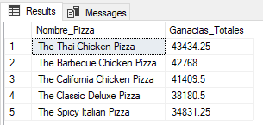

# H. Bottom 5 Pizzas por ganacias

SELECT Top 5 pizza_name AS Nombre_Pizza,

SUM(total_price) AS Ganancias_Totales

FROM pizza_sales

GROUP BY pizza_name

ORDER BY Ganacias Totales ASC

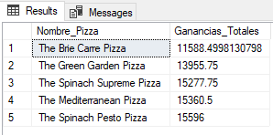

# I. Top 5 Pizzas por cantidad

SELECT Top 5 pizza_name AS Nombre_Pizza,

SUM(quantity) AS Pizzas_Totales_Vendidas

FROM pizza_sales

GROUP BY pizza_name

ORDER BY Pizzas_Totales_Vendidas DESC

***Output***

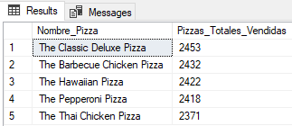

# J. Bottom 5 Pizzas por cantidad

SELECT TOP 5 pizza_name AS Nombre_Pizza,

SUM(quantity) AS Pizzas_Totales_Vendidas

FROM pizza_sales

GROUP BY pizza_name

ORDER BY Pizzas_Totales_Vendidas ASC

***Output:***

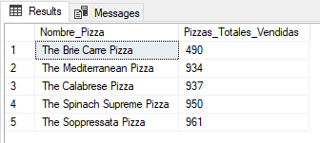

# K. Top 5 Pizzas por total de ordenes

SELECT Top 5 pizza_name AS Nombre_Pizza, COUNT(DISTINCT order_id) AS Total_De_Ordenes

FROM pizza_sales

GROUP BY pizza_name

ORDER BY Total_De_Ordenes DESC

***Output:***

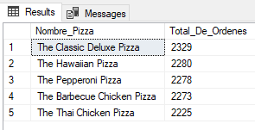

# L. Borrom 5 Pizzas por total de ordenes

SELECT Top 5 pizza_name AS Nombre_Pizza, COUNT(DISTINCT order_id) AS Total_De_Ordenes

FROM pizza_sales

GROUP BY pizza_name

ORDER BY Total_De_Ordenes ASC

***Output:***

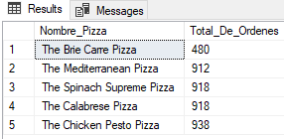

# NOTA

Si se quiere aplicar filtros a las consultas para los resultados generals o especificamente para las columnas “pizza_category” o “pizza_size” se puede usar la clausula WHERE, seguida de alguno de los siguientes ejemplos:

SELECT Top 5 pizza_name, COUNT(DISTINCT order_id) AS Total_Orders

FROM pizza_sales

WHERE pizza_category = 'Classic'

GROUP BY pizza_name

ORDER BY Total_Orders ASC

SELECT pizza_category AS Categoria_Pizza, SUM(quantity) as Cantidad_Total_Vendida

FROM pizza_sales

WHERE MONTH(order_date) = 2

GROUP BY pizza_category

ORDER BY Total_Quantity_Sold DESC